SATISH CHANDRA MEMORIAL SCHOOL
HIGHER ORDER THINKING SKILL TEST (2024-25)
IX
MATHEMATICS (041)
Time allowed: 30 min Maximum Marks: 4 x 4 = 16
Q1. Q1.If A = 0.36363636........ and B= 0.636363...... , then what is the value of
$\frac{1}{A}+\frac{1}{B}$ ?
Q2. Find the percentage increase in the area of a triangle if its each side is doubled?
Q3. In the figure below, it is given that AB = CF, EF = BD and ∠𝐴𝐹𝐸=∠𝐶𝐵𝐷. Prove that Δ𝐴𝐹𝐸≅Δ𝐶𝐵𝐷
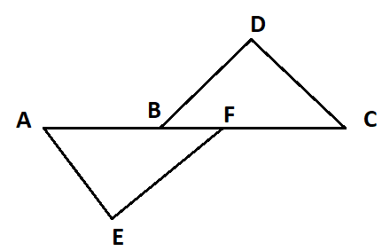

Q4. Use Heron’s formula to find area of an equilateral triangle of side ‘a’ units.

